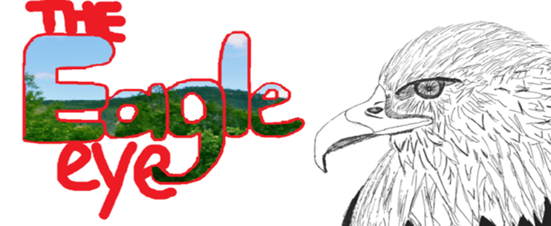

SCHOOL EVENTS
We Give Thanks: An 8th Grade Farewell
By: Monikka Macaranas and Daniela Parada
The Eighth grade class would like to thank St. John Eudes faculty and staff for providing us a gratifying environment for our Catholic education. Without the moral support of teachers and family, we wouldn’t be where we are today. From fundraisers to field trips we have been blessed with the opportunities that have been given to us. Throughout these past years at St. John Eudes School, it has been an incredible journey with our friends who have now become family. This class has spiritually and mentally grown because of our time at St. John Eudes. The memories we have created here are ones that will be remembered for the rest of our lives. We hope that one day we may leave a legacy for all to remember our time here at St. John Eudes. Of all the years of hard work and determinatio to give us the best education possible, we would like the give a big thank you to everyone.

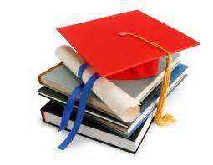
Photo Credit: www.limcollege.edu

Easter Egg Hunt
By: Michelle Uyanga
This year, SJE’s annual Easter Egg Hunt for Kindergarteners to Second Graders was a blast as it usually is! Many of the younger students thoroughly enjoyed it. Kindergartener, Gavin Unger says “I got to see the Easter Bunny! It was so fun!” And also, a first grader named Sarah Collins says “I got so many eggs with many treats! Coloring the eggs was fun too!” The Easter Egg Hunt took place in the field. And the other middle school kids remember how fun and exciting the Easter Egg Hunt was. A seventh grader named Sabrina Cervantes says “I remember the Easter Egg Hunt when I was little. It was so fun!” Easter egg hunts are very exciting and can make any child happy. And also, the Easter bunny visited St John Eudes and it make the children very happy. They also got to die eggs. Therefore, the Easter Egg Hunt for this year was very exciting for the kinder and first graders and many of the kids in middle school remember experiencing it.

Farewell to the 8th grade Class
By: Matthew Yuhico
Dear Class of 2013,

As your last day at St. John Eudes quickly approaches, you have all chosen high schools and look forward to the future. However, look back at the great memories here at St. John Eudes and the many things you have learned. Many of you have received the majority of your education here. The familiarity of the teachers that you see and the little students who adore you will be gone. But we appreciate, more than ever, the things we have learned that have helped to make us the people we all are today. You have been provided with a quality education since your first day here. The teachers have taught this to you so you could work to the best of your ability. You have shown the importance of kindness and generosity towards others. Your success in the future can partly be attributed to our years at St. John Eudes School.

While we realize many of you will have to part ways with the friends you have made, the teachers you know so well, and the good times you all have had with them here will never be forgotten. They have helped you to make your time here such a great experience. We are hopeful for your future, yet you might be nervous about leaving the place where you have spent so much of your time. Again, we thank all of you, who have contributed to our great memories. We realize that, without you, our wonderful school community would not be quite complete. Thank you and goodbye Eighth Grade. We will miss you very much!

Curricular Trips
By: Daniel Ferreiro and David “Kawika” Austin
This year, the students of SJE’s fourth through eighth grades went on a series of field trips to some exciting sites. Some of the trips that took place this year included: the 6th graders’ trip to the Japanese American National Museum and the California Science Center; the 7th graders’ trip to the LACMA and the California Science Center; the 8th graders’ trip to the Jet Propulsion Laboratory (JPL); the 4th graders’ trip to the Leonis Adobe Museum; and a 4th and 5th grade combined field trip to the California Science Center.
These places all provided our students a variety of enriching learning experiences. The 6th grade class recounts their trip to the Japanese American National Museum as being "fascinating" and "intriguing" with all of its historical artifacts like the display of a real medal of honor won by Japanese American soldiers during WWII and a barrack moved from the Manzanar internment camp. Similarly, the 8th graders had a lovely time at JPL, noting that they saw many interesting space program items and state of the art equipment. While there, they also had the opportunity to go into JPL’s Mission Control room, where all the action and magic surrounding Curiosity’s landing happened just a little under a year ago. The 7th graders also enjoyed their visit at the LACMA, admiring the numerous paintings and artwork from several talented artists displayed throughout the LACMA, which further sparked their interest in the subject. During their time at the LACMA, the 7th graders participated in some exciting yet educational docent-led activities, some of which included art lessons. At the Leonis Adobe Museum, the fourth graders had the opportunity to reenact and relive the early settlers of our great state of California. Needless to say, the 4th graders had a marvelous time!
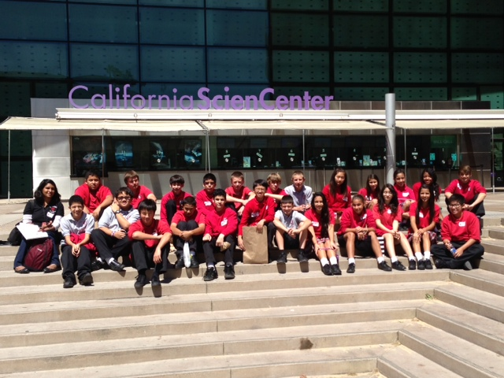
The California Science Center was a very popular curricular trip destination for SJE students this year, as the 4th, 5th, 6th and 7th graders all got a chance to visit the center at some point this year. Of course, the biggest attraction there was the Space Shuttle Endeavor, which was breath-taking and awe-inspiring to behold. During their visits there, the 6th and 7th graders also had the opportunity to participate in some exciting labs facilitated by the educational staff at the CSC. The 7th graders dissected a cow eye for their Discovery Lab, while the 6th graders had fun experimenting and playing with sand to study erosion.
In summary, the many educational field trips in which SJE students get to partake are just one more reason as to what makes SJE such wonderful school!
7th Grade Class at the California Science Center

Prayer Corner
Mother Mary: Our Mother and Queen
By: John Francis
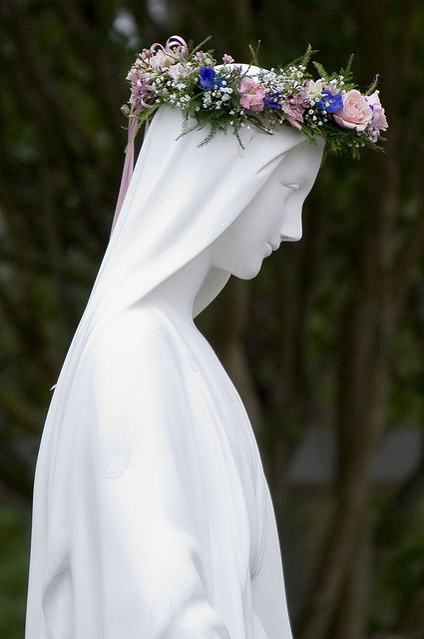
Mary, the Mother of our savior, Jesus, was honored at the May Crowning Ceremony on May 10th, 2013. This beautiful event took place in the church. The Second-graders and the Eighth-graders partook in one of the most sacred and blessed ceremonies of the year. The Second Graders wore their First Holy Communion garments, which they wore on their special day just a few weeks prior, and the Eighth-graders came dressed in their best church attire in order to honor our Blessed Mother. Mary was crowned with a crown of beautiful roses, and as we joined in praying the rosary, each class decorated the feet of our mother with their own flowers from home. All in all, May Crowning was a very holy event to honor the Mother of God, Mary.

SPOTLIGHT FEATURe

Getting to Know Ms. Smith
By: Celine Levesque
Ms. Smith joined the SJE family a few months ago when Mrs. Rice left on maternity leave. She has grown to love the students and the Catholic environment of St. John Eudes School. In order to welcome our newest faculty member and to get to her know a little better, I went over to the second grade room to interview Ms. Smith.

What do you like most about SJE?
"I like that all the students learn to follow the way of Jesus and I live to spend every day with children of all ages caring and watching their reactions or thoughts to academics and life."

Why did you choose teaching as a career?
"I believe that I have lots of patience towards children. People don't give children the respect that they deserve. "

What is your favorite subject to teach students?
"Language arts."

Do you like teaching second grade or would you like to teach other grades?
" I like the primary grades (k-4), because it's fun to see kids learn to read and write."

Recently the second graders made their first communion, a very important part of their religious life. Ms. Smith was here for them during this special time and I am sure the students will always remember her for guiding them through this special sacrament. Thank you Ms. Smith for helping children learn and grow in academics and faith!

Life So Far: A Reflection
By: Hannah Banks-Thompson

Excitement filled the air as we stepped outside and threw our red and white caps in unison. Overwhelmed with mixed feelings I stood with my friends and classmates. We have all heard the "Congratulations!" or the "I'll miss you"s, but now the time has come and the realization has overcome me. These people that I have seen almost everyday for nine years, I will most likely not see again, but in retrospect I realize that the friendships that have stayed strong for years will continue. I felt a million things in that one second interval of throwing my white cap that it felt like years passed. Memories flashed before my eyes, years and years of memories, and so did the years of knowledge gained from my ABCs and 123s to literature and algebraic formulas. While many will say this is just the beginning, my life has already begun and high school will just be the continuation with years and years to come.

Sports

Girls’ A Team Softball
By: Leilani Andazola

Girls A Team sports has had many great practices over these last few weeks! Although the team hasn’t won any games, the spirit of teamwork and trying their best, is a win for the teammates and the rest of SJE! Coach Gobeli is a spirited coach assuring each and every teammate that the most important part of playing a sport is to have fun. As the sports’ season comes to a close we would all like to congratulate all the teammates for a great season!

After School Sports
By: Ms. Tharayil
Much like the first two trimesters, the third trimester of After School Sports was filled with athleticism, talent, competition, and of course, fun! The Boys A and B teams enjoyed overall successful volleyball seasons, while the Girls A and B teams also had wonderful softball seasons. All the players and their coaches worked hard and put forth their best efforts in making this third trimester of sports a truly memorable one. A big thank you to our faculty and parent coaches, who continually work hard to help students realize their tremendous athletic potentials, while helping them develop a strong character!

COmics

Dino-Rawr!
By: Angel Castro and Michael Del Real
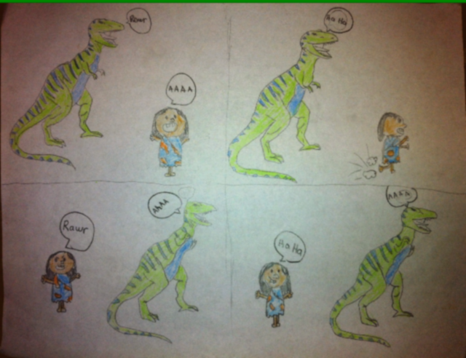
Newspaper Staff
CONTRIBUTORS
Leilani Andazola
David “Kawika” Austin
Hannah Banks-Thompson
Angel Castro
Michael Del Real
Daniel Ferreiro
John Francis
Celine Levesque
Monikka Macaranas
Daniela Parada
Michelle Uyanaga
Matthew Yuhico

EDITORS-IN-CHIEF
Daniela Parada
John Francis
Brian Gobeli

FACULTY ADVISOR
Ms. Sneha Tharayil

