Active and Passive Voice Practice
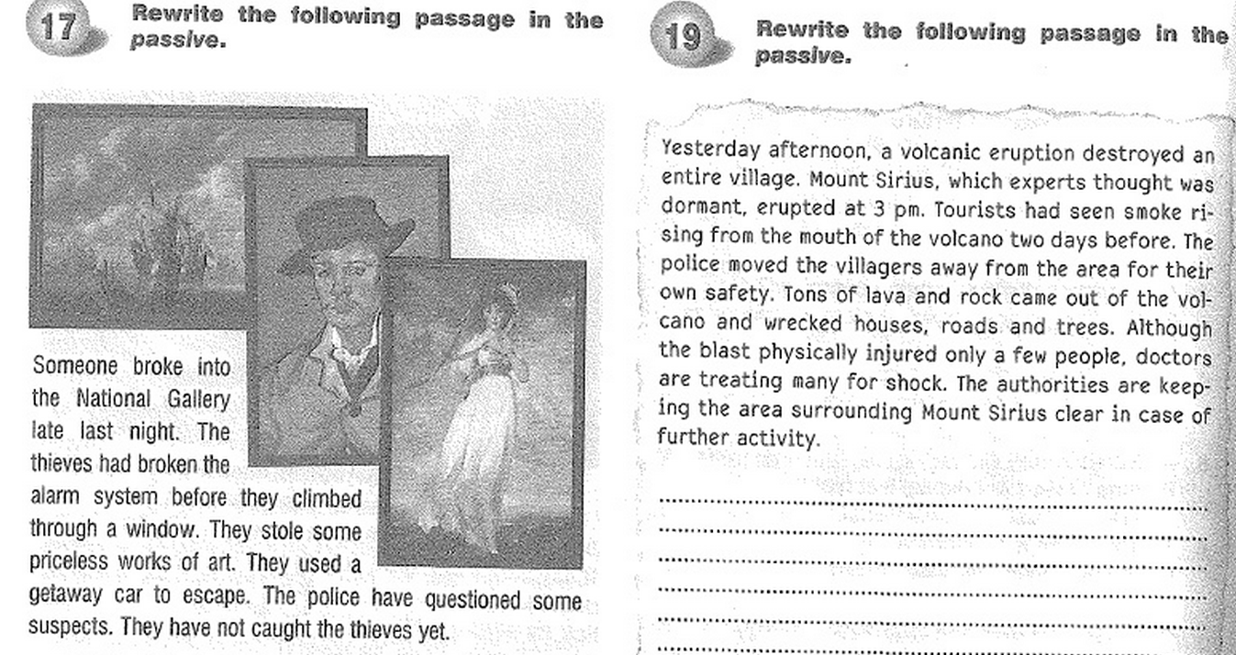

Exercise 17:
__________________________________________________________________________________________________________________________________________________________________________________________________________________________________________________________________________________________________________________________________________________________________________________________________________________________________________________________________________________________________________________________________________________________________________________________________________________________________________________________________________________________________________________________________________________________________________________________________________________________________________________________________________________
Exercise 19:
__________________________________________________________________________________________________________________________________________________________________________________________________________________________________________________________________________________________________________________________________________________________________________________________________________________________________________________________________________________________________________________________________________________________________________________________________________________________________________________________________________________________________________________________________________________________________________________________________________________________________________________________________________________

