Astronomy Unit (Chapter 17-20) Test
Study Guide

Directions: Answer the following questions thoroughly and completely. Use your notes AS WELL AS your textbook to help you. Using other sources would also be advisable.

- Define what a star is.

- Explain how a star’s temperature and color are related to each other. What color of stars tend to be the coolest and what are the hottest?

- What nuclear process fuels the burning in a star? What is the reaction that occurs (name specifically what and how many atoms are involved)?

- What is a spectrograph and how can you use it to determine a star’s composition?

- When measuring the “magnitude” of a star, what is being measured? What is the difference between apparent magnitude vs. absolute magnitude?

- How are distances to stars calculated?

- Explain what stellar parallax is. Draw a diagram.

- How does a star’s actual motion compare to its absolute motion?

- How do stars form? Explain the formation process.

- Depending on size, list the general and most likely path of stellar evolution for the following stars:
- Small star

- Medium (Sun-sized star)

- Large Star

- Extremely large star

- Define the following:
  - Red giant:

  - White Dwarf:

  - Supernova:

  - Neutron Star:

  - Black Hole:

- What are the major characteristics by which astronomers classify stars?

- What is the HR diagram? What is its function? What variables are needed to plot stars on the HR diagram?

- What are the outer and inner layers of the sun? Be able to label a diagram of the sun (ignore label 8 on the following diagram).
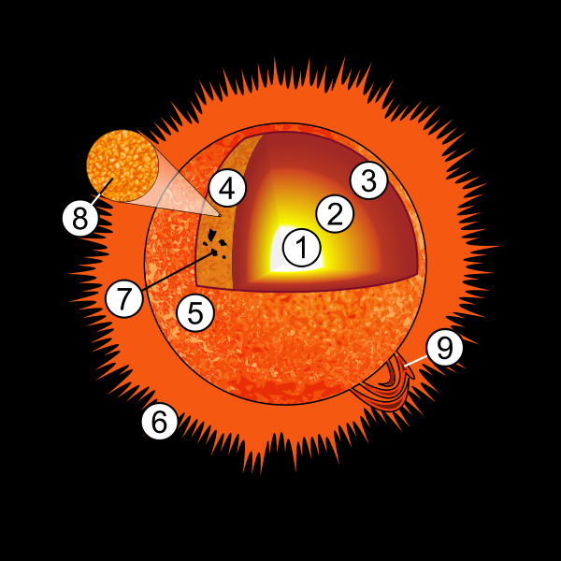
- Define the following and know how they form:
  - Solar Winds:

  - Solar Flares:

  - Aurora Borealis:

  - Sun Spots:

- What is a light year? How long is one light year? Why use light years to measure spaces between objects in space?

- Explain how looking at the light from an object that is several hundred or thousands of light years away is like looking into the past?

- What is an astronomical unit (AU)?

- What is a galaxy?

- What are galaxies classified by?

- What are the three types of galaxies and DEFINE THEIR GENERAL CHARACTERISTICS?

- What type of galaxy is the Milky way?

- Why is our position in the Milky Way ideal for us and conducive to space exploration (consider the factor of the vastness of the universe/space)?

