Introductory Paragraph Practice

Instructions
Write an introductory paragraph WITH A STRONG THESIS STATEMENT (don’t forget to take a position on the topic) for each of the following topics.

FIRST, COME UP WITH YOUR THESIS STATEMENT (it will go at the end of your paragraph thought).
THEN, write your hook and background.

- Topic: The effects of genetically engineered food on human health.
  - Thesis Statement: _______________________________________________________________________________________________________________________________________________________________________________________________________________________.

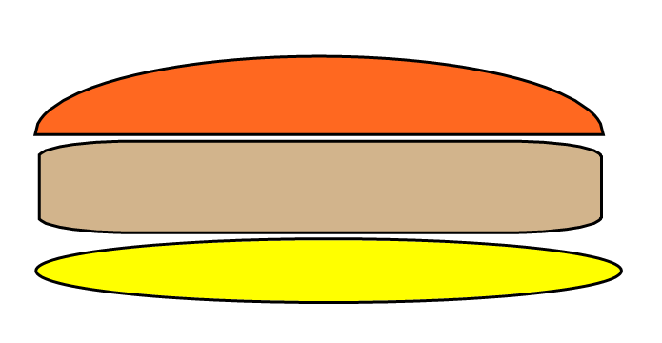
Hook
Thesis Statement
Develop Background

Introduction Paragraph:
________________________________________________________________________________________________________________________________________________________________________________________________________________________________________________________________________________________________________________________________________________________________________________________________________________________________________________________________________________________________________________________________________________________________________________________________________________________________________________________________________________________________________________

- Topic: How and why the founding fathers drafted the Bill of Rights.
  - Thesis Statement: _______________________________________________________________________________________________________________________________________________________________________________________________________________________.

Hook
Thesis Statement
Thesis Statement

Introduction Paragraph:
______________________________________________________________________________________________________________________________________________________________________________________________________________________________________________________________________________________________________________________________________________________________________________________________________________________________________________________________________________________________________________________________________________________________________________________________________________________________________________________________________________________________________________________________
________________________________________________________________________________________________________________________________________________________________________________________________________________________________________________________________________________________________________________________________________________________________________________________________________________________________________________________________________________________________________________________________________________________________________________________________________________________________________________________________________________________________________________________________________________________________________________________________________________________________________________________________________________________
- Topic: The cost of space exploration
- Thesis Statement: _______________________________________________________________________________________________________________________________________________________________________________________________________________________.

Hook
Thesis Statement
Thesis Statement

Introduction Paragraph:
______________________________________________________________________________________________________________________________________________________________________________________________________________________________________________________________________________________________________________________________________________________________________________________________________________________________________________________________________________________________________________________________________________________________________________________________________________________________________________________________________________________________________________________________
__________________________________________________________________________________________________________________________________________________________________________________________________________________________________________________________________________________________________________________________________________________________________________________________________________________________________________________________________________________________________________________________________________________________________________________________________________________________________________________________________________________________________________________________________________________________________________________________________________________________________________________________________________________________

