**Introductory Paragraph Practice**

***Instructions***

*Write an introductory paragraph WITH A STRONG THESIS STATEMENT (don’t forget to take a position on the topic)*for each of the following topics.

*FIRST, COME UP WITH YOUR THESIS STATEMENT (it will go* ***at the end*** *of your paragraph thought).*

*THEN, write your hook and background.*

1. *Topic:* The effects of genetically engineered food on human health.
   1. **Thesis Statement:** _______________________________________________________________________________________________________________________________________________________________________________________________________________________.

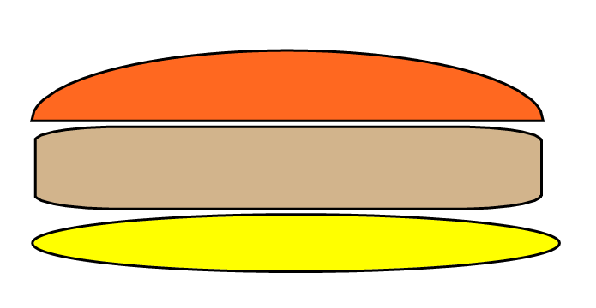

**Hook**

**Thesis Statement**

**Background Context**

**Introduction Paragraph:**

________________________________________________________________________________________________________________________________________________________________________________________________________________________________________________________________________________________________________________________________________________________________________________________________________________________________________________________________________________________________________________________________________________________________________________________________________________________________________________________________________________________________________________

1. *Topic:* How and why the founding fathers drafted the Bill of Rights.
   1. **Thesis Statement:** _______________________________________________________________________________________________________________________________________________________________________________________________________________________.



**Hook**

**Thesis Statement**

**Background Context**

**Introduction Paragraph:**

______________________________________________________________________________________________________________________________________________________________________________________________________________________________________________________________________________________________________________________________________________________________________________________________________________________________________________________________________________________________________________________________________________________________________________________________________________________________________________________________________________________________________________________________

________________________________________________________________________________________________________________________________________________________________________________________________________________________________________________________________________________________________________________________________________________________________________________________________________________________________________________________________________________________________________________________________________________________________________________________________________________________________________________________________________________________________________________________________________________________________________________________________________________________________________________________________________________________

1. *Topic:* The cost of space exploration
2. **Thesis Statement:** _______________________________________________________________________________________________________________________________________________________________________________________________________________________.



**Hook**

**Thesis Statement**

**Background Context**

**Introduction Paragraph:**

______________________________________________________________________________________________________________________________________________________________________________________________________________________________________________________________________________________________________________________________________________________________________________________________________________________________________________________________________________________________________________________________________________________________________________________________________________________________________________________________________________________________________________________________

__________________________________________________________________________________________________________________________________________________________________________________________________________________________________________________________________________________________________________________________________________________________________________________________________________________________________________________________________________________________________________________________________________________________________________________________________________________________________________________________________________________________________________________________________________________________________________________________________________________________________________________________________________________________